**Well Bot – Global Wellness Assistant Chatbot:**

**Project Documentation**

(Team: Meghana, Aishwarya, Akash, Gopichand)

**1. Project Overview**

**Problem Statement**

Access to **reliable, non-diagnostic health and wellness information** is often fragmented, language-dependent, or behind paywalls, creating a significant barrier to proactive self-care, especially in underserved global communities. Existing online advice can be misleading or lack authoritative grounding. The core problem WellBot addresses is the need for a **secure, universally accessible, multilingual conversational tool** that delivers evidence-based, public health-aligned guidance (sourced from organizations like WHO and CDC) directly to users through an intuitive, non-medical interface.

**1.1. Introduction and Purpose**

This report details the design, development, and implementation of **WellBot**, a multilingual, AI-powered conversational agent designed to serve as a global wellness assistant. The primary objective of WellBot is to democratize access to reliable, non-diagnostic health and wellness information by leveraging modern conversational AI technologies. It provides personalized, self-help guidance inspired by authoritative sources, promoting proactive health management for its users.

**1.2. Scope and Audience**

The system’s scope includes secure user management, a robust, multilingual conversational engine, and an intuitive web interface backed by a structured knowledge base.

* **Functional Scope:** Includes user authentication, personalized profile settings, real-time multilingual chat, knowledge retrieval, and administrative control over content and feedback.
* **Non-Functional Scope:** Focuses on security (JWT), scalability (Rasa/Flask microservices), responsiveness (UI/UX), and data persistence (SQLite).

The primary users are the **general public** seeking non-diagnostic wellness advice. Secondary audiences include the project **developers and maintainers**, and the **system administrators** managing the knowledge base.

**1.3. Primary Technology Stack**

WellBot is built on a modular, open-source technology stack, ensuring flexibility, maintainability, and clear separation of concerns between the web server, database, and conversational AI.

* **Backend & Framework (Flask - Python):** Acts as the RESTful API server, handling authentication and request routing.
* **Authentication (Flask-JWT-Extended):** Manages secure token-based authentication using HTTP-only cookies for persistent sessions.
* **Conversational AI (Rasa - NLU + Core):** Provides Natural Language Understanding (NLU) for intent/entity recognition and Dialogue Management (Core) for conversation flow.
* **Database (SQLite):** A local, file-based database used for persistent storage of user profiles and the central health knowledge base.
* **ORM (SQLAlchemy):** The Object-Relational Mapper facilitating efficient, abstract, and secure Python-based database interactions.
* **Frontend (HTML, CSS, JavaScript):** Handles client-side logic for user interfaces (login, registration, chat) and dynamic interaction with the Flask API.

**1.4. Guiding Principles: Public Health Reference**

The core content of WellBot’s knowledge base is synthesized from guidelines provided by reputable public health organizations, including the **World Health Organization (WHO)** and the **Centers for Disease Control and Prevention (CDC)**. This foundational principle ensures that all guidance provided is non-diagnostic, evidence-based, and aligned with global public health standards.

**2. System Architecture**

WellBot employs a **Three-Layer Architectural Model** to ensure decoupling and scalability. The system is composed of four main components communicating via HTTP: the **Flask Web Server** (handles user authentication and routing), the **Rasa Server** (processes NLP and dialogue flow), the **Rasa Action Server** (executes custom business logic and database queries), and the **SQLite Database** (persistent data storage). Requests flow securely from the frontend, authenticated by Flask, passed to Rasa for processing, and finally routed to the Action Server to retrieve multilingual knowledge.

**2.1. Three-Layer Architectural Model**

WellBot operates on a clear, three-layer architecture to maximize decoupling, scalability, and maintainability:

* **Presentation Layer (Frontend):** Handles all user interactions (login, chat, profile updates).
* **Application Layer (Flask/Rasa Core):** Manages business logic, authentication, request routing, and dialogue flow.
* **Data Layer (SQLite/SQLAlchemy/Rasa Action Server):** Responsible for persistent data storage and secure knowledge retrieval.

**2.2. Component Breakdown**

Each component plays a specialized role and communicates via defined protocols:

* **User Interface:** Renders UI templates, captures user input, and initiates AJAX requests. It communicates using HTTP/S (to Flask).
* **Flask Web Server (Port 5000):** Responsible for user authentication, JWT issuance, session validation, static file serving, and proxying chat requests to Rasa. It communicates via HTTP/S (External) and HTTP (Internal to Rasa).
* **Rasa Server (Port 5005):** Processes raw text (NLU), manages dialogue state (Core), and determines the appropriate next action. It communicates via HTTP (Internal to Flask/Action Server).
* **Rasa Action Server (Port 5055):** Executes custom business logic, primarily the database query for the health knowledge base. It communicates via HTTP (Internal to Rasa) and SQLAlchemy ORM (to SQLite).
* **SQLite Database:** Provides persistent storage for User and HealthKnowledge data, accessed through the SQLAlchemy ORM.

**2.3. Data and Request Flow Diagram (Conceptual)**

The chat interaction workflow follows this critical sequential process:

1. **User Sends Message:** The Frontend captures user input and sends a POST request to Flask's /chat endpoint. The request includes the message and the secured JWT Cookie.
2. **Flask Authentication:** Flask validates the JWT. If valid, it extracts the user_id and the stored preferred_language.
3. **Flask to Rasa:** Flask forwards the user message and the language metadata (as a custom channel or slot update) to the Rasa server.
4. **Rasa NLU Processing:** Rasa NLU detects the conversation's intent (e.g., symptom_inquiry) and extracts relevant entities (e.g., duration, symptom).
5. **Rasa Core Dialogue:** Rasa Core determines the next action. For knowledge queries, it triggers the custom action: action_query_knowledge_base.
6. **Rasa to Action Server:** Rasa sends a request to the Action Server.
7. **Action Server Execution:** The action_query_knowledge_base uses SQLAlchemy to query the SQLite database, utilizing the detected intent and the user's preferred language to retrieve the correct multilingual response.
8. **Response Return:** The structured response (in the correct language) travels back through the Rasa Server, then to the Flask Server.
9. **Flask to Frontend:** Flask relays the final response to the frontend, where JavaScript dynamically updates the chat.html interface.

**3. Milestone 1 – Core Foundation: Authentication & User Profiles**

This milestone established the **secure foundation** of the application. It focuses on implementing **robust user management** by defining the database schema, creating secure user registration with **password hashing**, and integrating **token-based session management (JWT)** using HTTP-only cookies to protect user sessions and enforce access control across the web application.

**3.1. Database Schema: User Management**

The persistence layer for user data is managed by SQLAlchemy and stored in SQLite. The primary table, **User**, is defined by the following fields:

* **id:** Integer, Primary Key, Auto-Increment.
* **email:** String, Unique, Not Null.
* **password_hash:** String, Not Null.
* **age_group:** String, Nullable.
* **preferred_language:** String, Not Null.
* **is_admin:** Boolean, Default: False.

**3.2. User Registration and Hashing**

The /register endpoint (POST) handles new user creation. Passwords are never stored in plaintext.

* **Hashing:** Passwords are processed through a strong hashing library (e.g., Werkzeug's security module) before being stored as password_hash.
* **Default Settings:** Default preferred_language is 'en' and is_admin is set to False.
* **Key Initialization:** The very first registered user is automatically designated as the initial administrator.

**3.3. Secure Session Management (JWT)**

Security is paramount, implemented using Flask-JWT-Extended with HTTP-only cookies.

* **Login (/login):** Upon verification, a JWT access token is generated, including user_id, age_group, and preferred_language in its payload.
* **Security:** The token is transmitted via an **HTTP-only cookie**, preventing client-side JavaScript access and mitigating Cross-Site Scripting (XSS) risks.
* **Protected Endpoints:** All critical endpoints are decorated with @jwt_required(locations=["cookies"]).

**3.4. Page Access Control**

* **Unauthorized Access:** Server-side logic redirects unauthenticated users attempting to access /chat or /profile to the /login page.
* **Frontend Logic:** JavaScript modules handle token expiration and automatically redirect the client upon receiving a 401 Unauthorized response from a protected API call.

**4. Milestone 2 – Core System: Chatbot Integration & Web UI**

This milestone centered on building the **core conversational engine** and linking it to the web interface. It involved implementing the **Rasa NLU model** for intent recognition, designing the **structured HealthKnowledge database**, creating the Python utility for knowledge import, and developing the **Action Server logic** to query the database and retrieve relevant, non-diagnostic guidance. Finally, the basic chat UI was integrated with the Flask API.

**4.1. Rasa NLU Model Implementation**

The NLU model is trained to identify key intents:

* greet, goodbye, symptom_inquiry, first_aid_request, wellness_advice.

The Configuration (config.yml) utilizes a standard language-specific pipeline optimized for both English and Hindi text processing.

**4.2. Structured Health Knowledge Base Design**

The **HealthKnowledge** table stores the core intelligence of WellBot:

* id, intent\_name, keyword, response\_en, response\_hi, age\_group\_filter.

**4.3. Data Import Utility (load_knowledge.py)**

A dedicated Python script manages the ingestion of knowledge data. It reads from a standardized CSV, uses the **Pandas** library for data cleaning, and leverages **SQLAlchemy** to batch-insert or update entries in the HealthKnowledge table.

**4.4. Action Server (actions.py) Logic**

The custom action action_query_knowledge_base executes the business logic:

1. **Input:** Receives the intent and user metadata (language, age group).
2. **Query Construction:** Constructs a dynamic SQLAlchemy query.
3. **Filtering:** Filters the query by the user's preferred_language and applies the age_group_filter.
4. **Output:** Returns the retrieved, localized guidance text back to Rasa Core.

**4.5. Frontend Structure and Interactivity**

The frontend is a lightweight, responsive interface served by Flask.

* **Core Templates:** login.html, register.html, profile.html, and chat.html.
* **JavaScript Interactivity (chat.js):** Manages asynchronous message submission and handles the real-time display of bot responses.

**5. Milestone 3 – Expanded Features: Advanced NLP & Multilingual Capabilities**

The focus here was on achieving **global reach and improved intelligence**. This involved expanding the knowledge base content, introducing **multilingual capabilities** (Hindi support) by updating Rasa pipelines and training data, implementing **dynamic language output** based on user profiles, and integrating **advanced Entity Extraction** (duration, severity, location) to enable more nuanced and personalized advice retrieval. Crucially, **safety disclaimers** were also enforced.

**5.1. Knowledge Base Expansion Strategy**

Content was expanded to over 100 entries, focusing on a preventative and holistic wellness approach.

**New Content Categories:**

* Common Illnesses and Symptom Management, Preventive Measures, Wellness Recommendations, Chronic Condition Management.

**5.2. Safety and Compliance Disclaimers**

* **Disclaimer Implementation:** An automated utter_disclaimer action is triggered at the start of every new conversation session via a high-priority rule in rules.yml.
* **Content:** Explicitly states that WellBot provides **non-diagnostic guidance only**.

**5.3. Multilingual Rasa Configuration**

Hindi language support was introduced.

* **Configuration Update (config.yml):** The Rasa pipeline was updated to include language-agnostic components or separate models.
* **Training Data:** NLU examples were segregated into language-specific files (data/en/nlu.yml and data/hi/nlu.yml).

**5.4. Dynamic Language Output Implementation**

Response language is now determined by the user's stored profile preference.

* **Metadata Flow:** The Flask backend injects the user's preferred_language into the Rasa tracker's slot.
* **Action Server Logic:** action_query_knowledge_base uses this parameter to dynamically select the correct bilingual column from the HealthKnowledge table.

**5.5. Advanced Entity Extraction and Slot Filling**

Specific entities were introduced to improve personalization:

* duration, severity, location.

Training data was extensively updated in both English and Hindi to accurately recognize and extract these context variables.

**6. Milestone 4 – Admin Dashboard & System Optimization**

This final milestone focused on **maintenance, quality control, and system hardening**. Key components included building a protected **Admin Dashboard** for administrators, implementing the **Knowledge Base Management Module** (allowing CRUD operations on health content), integrating a **User Feedback System** for continuous improvement, and developing an **Analytics and Reporting** module. System hardening focused on robust **database session management** and improved exception handling for reliability.

**6.1. Admin Dashboard Features and Roles**

The admin dashboard is a protected Flask Blueprint (/admin) accessible only to users with the is_admin: True flag.

* **Core Role:** Content management, user feedback review, and system monitoring.
* **Access Control:** Requires JWT authentication and an additional server-side check for is_admin status.

**6.2. Knowledge Base Management Module**

This module allows administrators to maintain the quality and relevance of WellBot's advice.

* **Functionality:** Administrators can **Browse/Search** all entries in the HealthKnowledge table. Web forms enable **Add/Edit** and secure **Delete** operations for bilingual content.

**6.3. User Interaction Analytics and Reporting**

A dedicated analytics module provides insights into system usage.

**Key Metrics Displayed:**

* Total User Interactions, Top 10 Most Common Queried Intents, Distribution of Users by Age Group and Preferred Language, Average Feedback Rating.

**6.4. User Feedback System Design**

A feedback mechanism (Thumbs-up/Thumbs-down) was integrated into the chat interface.

* **Data Model (ChatFeedback Table):** Captures feedback data including user_id, knowledge_id, rating, comment, and timestamp.
* **Endpoint:** The /feedback endpoint handles the submission.

**6.5. System Hardening and Database Optimization**

* **Database Session Management:** Implemented robust SQLAlchemy session handling with proper rollback and commit logic to prevent concurrent operation errors.
* **Administrative Setup:** The first user created is automatically granted is_admin: True.
* **Exception Handling:** Enhanced error logging and graceful exception handling across Flask API endpoints.

**6.6. UI/UX Modernization Summary**

The frontend was refactored for improved aesthetics and usability, adopting a sleek design, responsive layout, and polished authentication flow.

**Dashboard:**

**Knowledge Base:**

**User, user query and Feedbacks:**

**Database schema:**

**📊 WellBot Database Schema Description**

The database schema is organized around a central USERS table, linking out to logs and data specific to each user. The knowledge base is modularized into Q&A and Tips tables.

**User and Core Tables**

**1. USERS (Primary Table)**

This is the main authentication and profile table.

* **PK (Primary Key):** id (user)
* session\_id
* created\_at
* language\_preference
* **Relationship:** Has a **1-to-many** relationship with CONVERSATIONS and EXERCISE LOGS.

**2. CONVERSATIONS**

Logs individual message exchanges for analytics and dialogue history.

* **PK (Primary Key):** conversation\_id
* message (text)
* sender (FK from USERS)
* timestamp
* language (for multilingual analysis)
* **Relationship:** Linked back to USERS with a **1-to-many** relationship (one user can have many conversations).

**3. EXERCISE LOGS**

Tracks user-reported exercise activity.

* **PK (Primary Key):** id (integer)
* **FK (Foreign Key):** user\_id (links to USERS table)
* exercise\_type
* exercise\_date
* sender (integer, FK)
* timestamp
* **Relationship:** Linked back to USERS with a **1-to-many** relationship (one user can have many exercise logs).

**Health Data and Knowledge Base Tables**

**4. USER HEALTH DATA**

Stores daily or periodic health metrics logged by the user.

* **PK (Primary Key):** user\_h\_id (NOT NULL)
* **FK (Foreign Key):** user\_b\_id (links to USERS table)
* water\_intake
* current\_mood
* sleep\_hours
* date
* **Relationship:** Has a **1-to-many** relationship with HEALTH QA (though the relationship flow on the diagram suggests that HEALTH QA links to USER HEALTH DATA via user\_h\_id which seems non-standard for Q&A, usually Q&A is static).

**5. HEALTH QA (Question & Answer)**

The primary knowledge base for specific health inquiries.

* **PK (Primary Key):** HEALTH\_QA
* question
* answer
* category
* authority\_references
* **Relationship:** Shares a **1-to-many** relationship with WELLNESS TIPS.

**6. WELLNESS TIPS**

Stores general wellness advice, potentially linked to specific health categories.

* **PK (Primary Key):** TIP
* **FK (Foreign Key):** WEALTH\_QA (links to HEALTH QA table)
* tip (the advice text)
* language
* category
* **Relationship:** Linked back to HEALTH QA with a **1-to-many** relationship.

**7. CONVERSATIONS (Secondary Entry)**

This seems to be a redundant or specialized logging table for message segments.

* **PK (Primary Key):** integer (likely message_id)
* **FK (Foreign Key):** conversation\_id (links to the main CONVERSATIONS table)
* message\_segment
* language
* timestamp
* **Note:** The structure suggests it might be intended for message fragmentation or slot tracking, though its definition in the diagram is slightly ambiguous compared to the main CONVERSATIONS table.

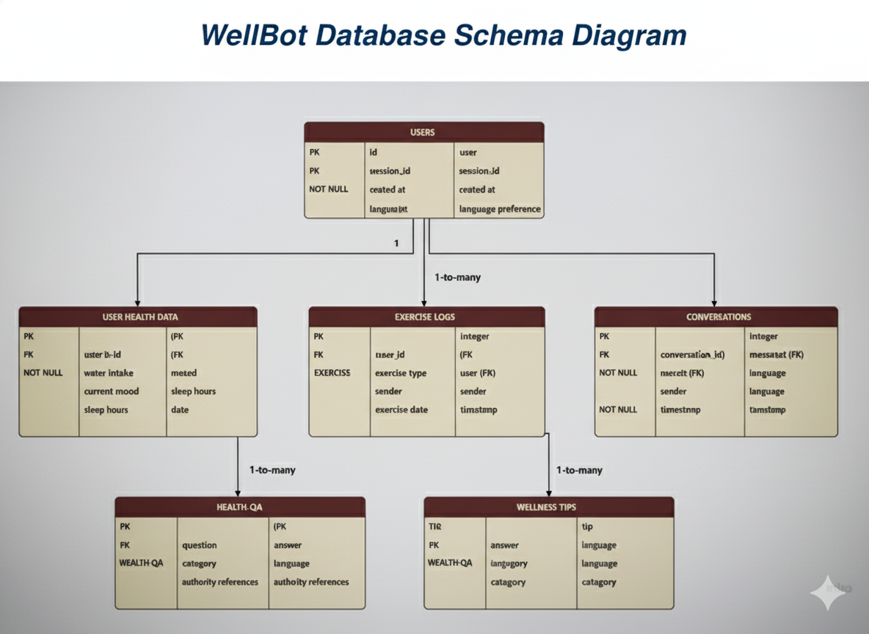

**Diagrams:**

**User Flow diagram:**

**Purpose:** Visualizes the **path a user takes** through a website or application to complete a specific goal. It's focused on the user experience (UX).

**What it shows:** A series of steps, screens (or pages), and **decision points** (e.g., a diamond shape for "Yes/No") from the entry point to the final desired action (conversion).

**Analogy:** A road map or flowchart for a customer's journey from finding a product online to completing the purchase checkout.

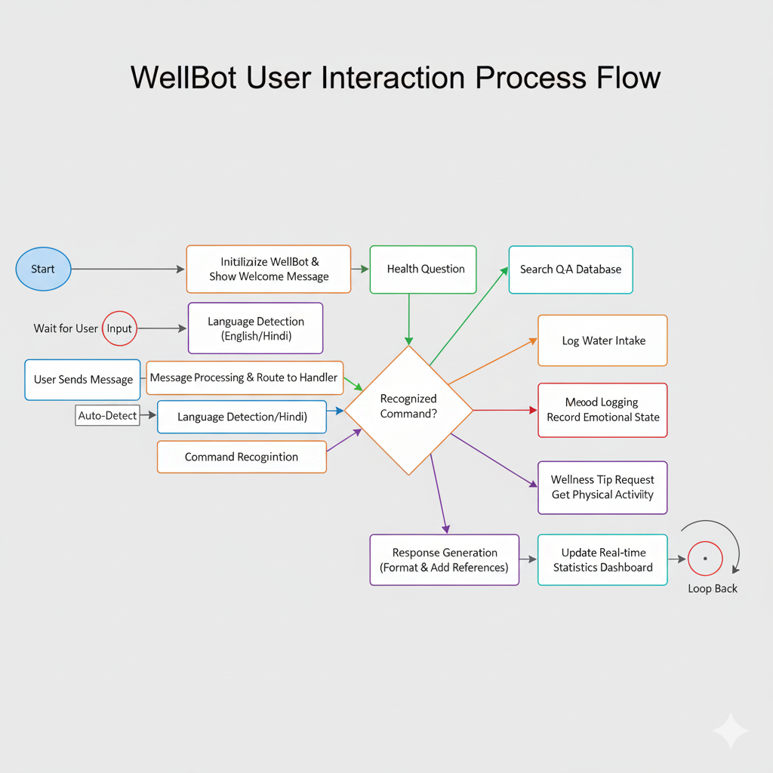

**Use case diagram:**

**Purpose:** Captures the **functional requirements** and high-level scope of a system from the **external user's perspective**.

**What it shows:** The **actors** (external users or other systems) and the primary **use cases** (the discrete functions/goals the system provides, shown as ovals), linked by association lines.

**Analogy:** A menu for a restaurant, listing everything the customer (actor) can order (use case).

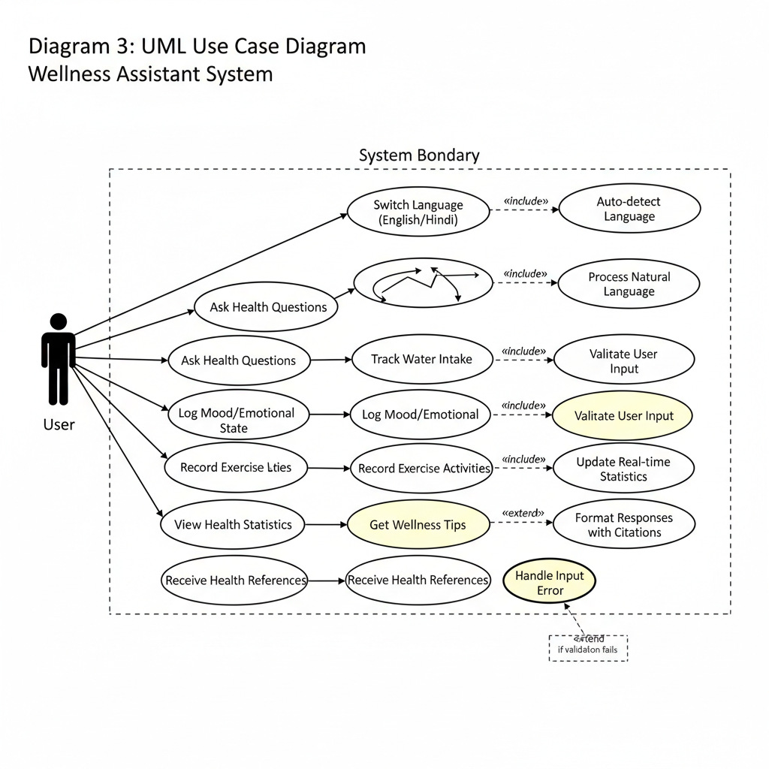

**Sequence Diagram:**

**Purpose:** Shows the **order of interactions** between objects or components in a system over time to complete a specific task or scenario.

**What it shows:** **Lifelines** (vertical lines representing objects/components) and **messages** (horizontal arrows) exchanged in the exact chronological sequence they occur. It focuses on the time-ordered logic.

**Analogy:** A script for a play, showing exactly which character (object) speaks (sends a message) to which other character and when.

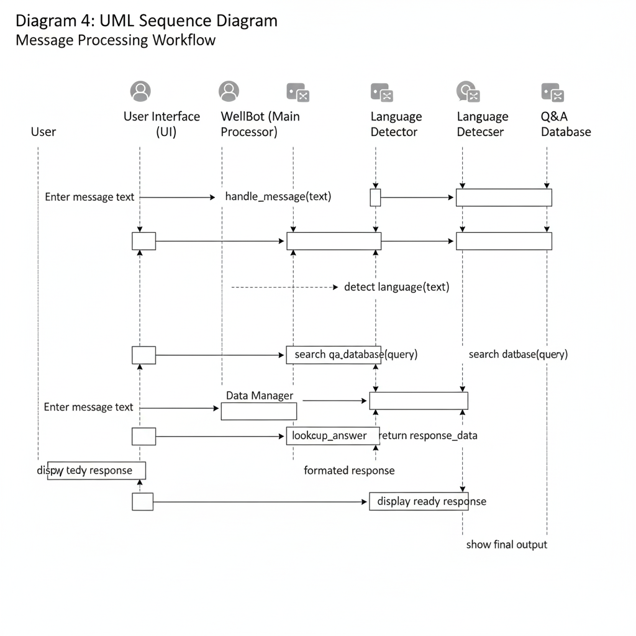

**Entity Relation diagram:**

**Purpose:** Models the **structure of a database**.

**What it shows:** The primary **entities** (tables or concepts) in a system, their **attributes** (columns), and the **relationships** between them, often detailing **cardinality** (one-to-one, one-to-many, etc.).

**Analogy:** A schematic showing all the key data points in a library (books, members, loans) and how they are linked.

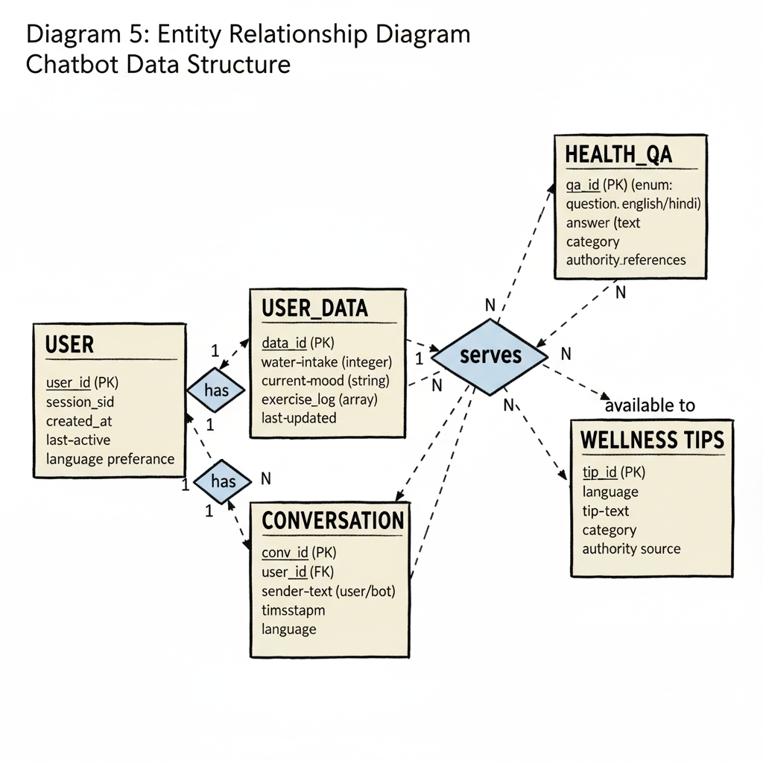

**Class Diagram:**

**Purpose:** Describes the **static structure** of an object-oriented system. It's the blueprint for the code.

**What it shows:** The system's **classes**, their **attributes** (data), **operations/methods** (functions), and the **relationships** (like inheritance, association, or aggregation) between them.

**Analogy:** The architectural blueprint of a house, detailing every component (room, wall, window) and how they are structurally connected.

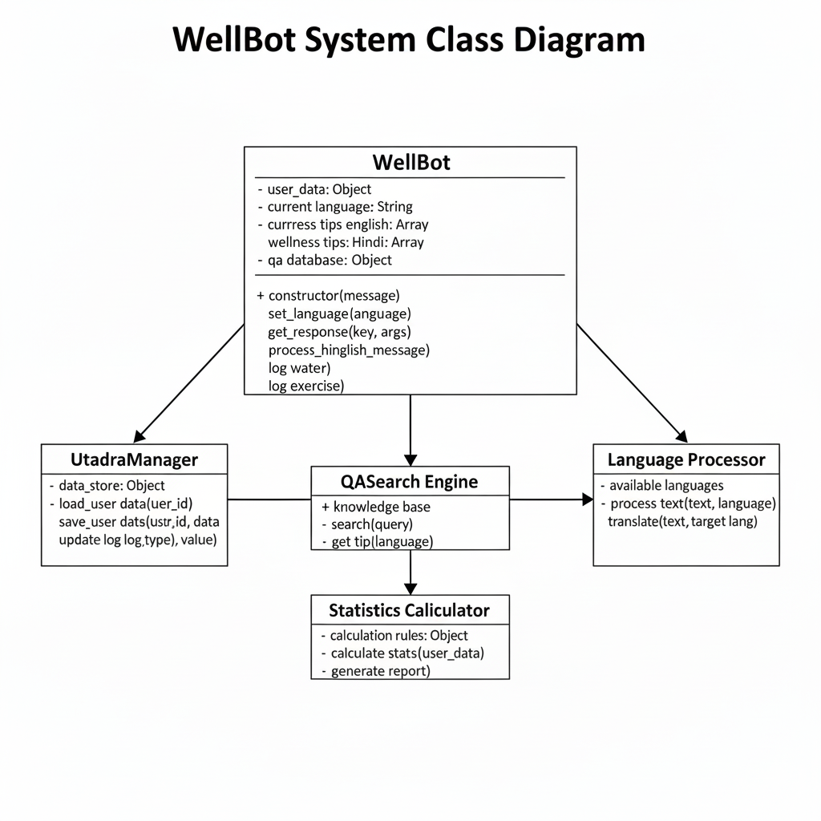

**7. Conclusion and Future Work**

**7.1. Project Summary**

WellBot successfully delivers a secure, multilingual, and data-driven wellness assistant built on a robust Flask/Rasa architecture. By integrating a customizable knowledge base with advanced NLP capabilities, it fulfills its primary goal of providing accessible, non-diagnostic guidance in both English and Hindi, all within a professional and responsive web application. The implementation of authentication, the Admin Dashboard, and the feedback system ensures the project is not only functional but also secure, maintainable, and iteratively scalable.

**7.2. Recommended Future Enhancements**

* **Integration:** Migrate from SQLite to a cloud-based database (e.g., **PostgreSQL, Firestore**) for global deployment and improved concurrency/scalability.
* **Conversational Flow:** Implement Forms/Flows for structured information gathering (e.g., asking about symptom duration, pain level) to enhance the conversational depth.
* **Language:** Addition of **Spanish and French** language support.
* **Personalization:** More extensive use of age_group and other profile data to customize advice more precisely.